**國科會補助專題研究計畫經費支出用途變更彙報表**

|  |  |  |  |
| --- | --- | --- | --- |
| 主持人： 執行機構：  計畫編號：NSTC  計畫名稱： 製表日期：  執行期限： | | | |
| 補助項目 | 核准文號 | 核准日期 | 變更內容 |
| 業務費 |  |  |  |
|  |  |  |
|  |  |  |
| 研究設備費 |  |  |  |
|  |  |  |
|  |  |  |
| 國外差旅費 |  |  |  |
|  |  |  |
|  |  |  |

註：

1.依國科會補助專題研究計畫經費處理原則第三點第四項規定彙報補助項目辦理變更之支出用途及經費（如業務費項下助理人員類別變更、國際合作研究計畫國外學者來臺費用項目新增或刪除等支出用途變更、研究設備購置項目變更、國外差旅費出國種類變更等），請簡要敘明變更核准文號、日期及內容，並於計畫結束辦理經費結報時，隨同收支明細報告表等文件一併函送國科會。

2.本表如不敷使用請自行調整或複印。

|  |  |  |  |
| --- | --- | --- | --- |
| **製表** | **主持人**  **(覆核)** | **單位系所**  **主管簽章** | **機關主管** |

一、彙報表填寫範例如下:

**本校填寫範例**

**國科會補助專題研究計畫經費支出用途變更彙報表(範例)**

|  |  |  |  |  |  |
| --- | --- | --- | --- | --- | --- |
| 主持人： | ○○○ | | | 執行機構： | 國立政治大學 |
| 計畫編號： | NSTC100-○○○○－H－○○○－○○○－ | | |  |  |
| 計畫名稱： | ○○○○○○○○○○○○○○○○○○ | | | 製表日期： | 102.01.15 |
| 執行期限： | 100.08.01～101.12.31 | | |  |  |
| 補助項目 | 核准文號 | 核准日期 | 變更內容 | | |
| 業務費 | 校內簽准 | 101.9.28 | 增列兼任助理研究人力費。 | | |
|  |  |  | | |
|  |  |  | | |
| 研究設備費 | 校內簽准 | 101.08.02 | 因計畫需要增購筆記型電腦1台。 | | |
|  |  |  | | |
|  |  |  | | |
| 國外差旅費 | 臺會綜二字第10100○○○○○號 | 101年10月25日 | 因計畫需要增列於○年○月○日赴美國休士頓出席○○國際會議，並追加經費新台幣○○元。 | | |
| 校內簽准 | 101.11.19 | 因○○○考量，取消○年○月○日赴中國大陸上海市移地研究計畫。 | | |
|  |  |  | | |

註：

1.依國科會補助專題研究計畫經費處理原則第三點第四項規定彙報補助項目辦理變更之支出用途及經費（如業務費項下助理人員類別變更、國際合作研究計畫國外學者來臺費用項目新增或刪除等支出用途變更、研究設備購置項目變更、國外差旅費出國種類變更等），請簡要敘明變更核准文號、日期及內容，並於計畫結束辦理經費結報時，隨同收支明細報告表等文件一併函送國科會。

2.本表如不敷使用請自行調整或複印。

研究助理

主持人

單位系所主管

校 長

|  |  |  |  |
| --- | --- | --- | --- |
| **製表** | **主持人**  **(覆核)** | **單位系所**  **主管簽章** | **機關主管** |

二、補充說明:

**(一)填報期間**

1.依國科會101年8月31日臺會綜二字第1010058874號函說明二所指「101年8月1日仍在執行及以後年度核定之計畫須填列（至101年7月31日止已執行結束之計畫免填）」，就展延之計畫而言，執行期間已變更為展延後期日，其101年8月1日仍在執行中，自需填列。

2.101年8月1日以前已執行之計畫(如98、99年起執行之計畫)僅需填列101年8月1日以後變更之情形，依修正前規定所為之變更無需填列。

**(二)填列範圍**

1.依國科會補助專題研究計畫經費處理原則第三點第二項及第三項規定辦理變更之事項，不含第三點第五項，故經費「流用」部分，無需填列。

【備註1】前開原則第三點第二項及第三項規定

第二項 同一補助項目內之支出用途於計畫執行期間經檢討確為研究計畫需要，執行機構得逕依其內部行政程序辦理變更，所需經費於該補助項目項下調整。但計畫內核有博士後研究人員費用者，如有賸餘不得調整至其他用途。

第三項 依前項規定辦理研究設備費變更者，其變更之設備單價達新臺幣五十萬元以上者，須於本會線上系統登錄。

【備註2】無需填列前開原則第三點第五項

第五項 任一補助項目經費如因研究計畫需要，須與其他補助項目互相流用時，如累計流出及流入均未超過計畫全程該項目原核定金額百分之五十者，執行機構得依內部行政程序辦理；如任一項累計流出或流入超過計畫全程該項目原核定金額百分之五十者，執行機構應事先報經本會同意，始得流用。但研究設備費流入後總額在新臺幣五萬元以下者，執行機構得依內部行政程序辦理，免報本會。

2.無需填列「延長執行期限」變更事項。

三、填寫彙報表時，請參閱國科會線上系統「專題變更紀錄(總列表)」。

（範例畫面）

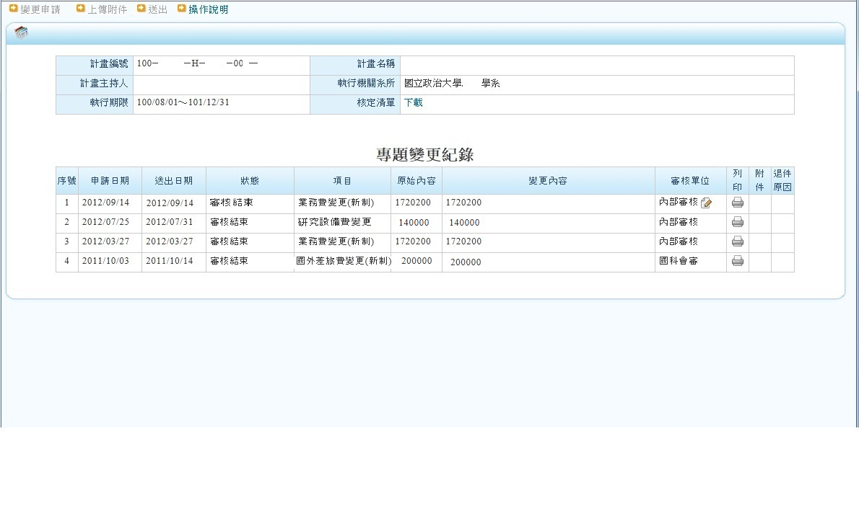

**National Science and Technology Council Research Project Budget Use Change Report**

|  |  |  |  |
| --- | --- | --- | --- |
| Principal investigator: Research conducting institutions:  Project Number:NSTC  Project Title: Report Date:  Project execution period: | | | |
| Subsidized Items | Approval Number | Approval Date | Change Details |
| Business expenses |  |  |  |
|  |  |  |
|  |  |  |
| Research Equipment Fees |  |  |  |
|  |  |  |
|  |  |  |
| Overseas Travel Expenses |  |  |  |
|  |  |  |
|  |  |  |

Notes:

1. According to Article 3, Paragraph 4 of the NSTC Principles for Handling Research Project Grants, please report any changes in the expenditure and budget of subsidized items (such as changes in the category of assistant personnel under business expenses, addition or deletion of expenses for foreign scholars visiting Taiwan in international cooperation research projects, changes in the purchase of research equipment, changes in the types of overseas travel expenses, etc.). Add the approval number, date, and content of the change on the above form. At the end of a project, when the research conducting institution is processing the expenditure report, submit the completed form along with the budget statement and other relevant budget documents to the NSTC upon project completion.
2. If the format of this form is not suitable for your budget changes, or if you need to add additional context for your budgetary changes, you may adjust and edit this form as necessary.

|  |  |  |  |
| --- | --- | --- | --- |
| Research assistant: | Principal investigator:  (PI) | Department Chair | President |
|  |  |  |  |

I. Example of Filling Out the Report Form:

(Example of Filling Out the Report Form by Our University)

**National Science and Technology Council Research Project Budget Use Change Report**

**(Example)**

Principal investigator: ○○○ Research conducting institutions: National Chengchi University

Project Number: NSTC100-○○○○－H－○○○－○○○－

Project Title: ○○○○○○○○○○○ Report Date: 100.08.01～101.12.31

Project execution Period: 100.08.01～101.12.31

|  |  |  |  |
| --- | --- | --- | --- |
| Subsidized Items | Approval Number | Approval Date | Change Details |
| Business expenses | Internal Approval | 101.9.28 | Adding pay for part-time assistants. |
|  |  |  |
| Research Equipment Fees | Internal Approval | 101.08.02 | Due to project needs, purchase an additional laptop. |
|  |  |  |
| Overseas Travel Expenses | Taihui Zong Er Zi No. 10100XXXXX | 101.10.25 | Due to project needs, a researcher will go to Houston, USA to attend the ○○ international conference on ○, ○, month ○, and additional funding will be NT$○○. |
| Internal Approval | 101.11.19 | Due to [specific reason], the off-site research research project to Shanghai, China on [specific date] is canceled. |
|  |  |  |

Notes:

1. According to Article 3, Paragraph 4 of the NSTC Principles for Handling Research Project Grants, please report any changes in the expenditure and budget of subsidized items (such as changes in the category of assistant personnel under business expenses, addition or deletion of expenses for foreign scholars visiting Taiwan in international cooperation research projects, changes in the purchase of research equipment, changes in the types of overseas travel expenses, etc.). Add the approval number, date, and content of the change on the above form. At the end of a project, when the research conducting institution is processing the expenditure report, submit the completed form along with the budget statement and other relevant budget documents to the NSTC upon project completion.
2. If the format of this form is not suitable for your budget changes, or if you need to add additional context for your budgetary changes, you may adjust and edit this form as necessary.

|  |  |  |  |
| --- | --- | --- | --- |
| Research assistant: | Principal investigator:  (PI) | Department Chair | President |
|  |  |  |  |

II. Supplementary Explanation:

1. Reporting Period

(1)According to the NSTC letter Taihui Zong Er Zi No. 1010058874 dated August 31, 2012, "Projects that are still ongoing as of August 1, 2012, and those approved in subsequent years must be reported (projects completed by July 31, 2012, do not need to be reported)." For extended projects, the execution period has changed to the extended end date, and projects still ongoing as of August 1, 2012, must be reported.

(2)For projects executed before August 1, 2012 (such as those starting in 2009 or 2010), only changes after August 1, 2012, need to be reported. Changes made according to the previous regulations do not need to be reported.

2. Reporting Scope

(1)Changes handled according to Article 3, Paragraphs 2 and 3 of the NSTC Subsidized Research Project Expenditure Handling Principles do not need to include Paragraph 5 of Article 3. Therefore, budget "reallocation" does not need to be reported.

[Note 1] Provisions of Article 3, Paragraphs 2 and 3 of the Handling Principles:

Paragraph 2: If the expenditure purpose within the same subsidized item needs to be changed during the project execution period upon review and confirmation of research project needs, the executing institution may handle the change according to its internal administrative procedures. The necessary funds can be adjusted within the same subsidized item. However, if there are surplus funds in the budget for postdoctoral researchers, they cannot be reallocated to other uses.

Paragraph 3: For changes in research equipment expenses handled according to the previous paragraph, if the unit price of the changed equipment reaches NT$500,000 or more, it must be registered in the NSTC's online system.

[Note 2] Provisions of Article 3, Paragraph 5 of the Handling Principles (which do not need to be reported):

Paragraph 5: If the budget for any subsidized item needs to be reallocated to other subsidized items due to research project needs, and the cumulative outflow and inflow do not exceed 50% of the originally approved amount for that item over the entire project period, the executing institution may handle it according to its internal administrative procedures. If the cumulative outflow or inflow exceeds 50% of the originally approved amount for any item, the executing institution must obtain prior approval from the NSTC before reallocating. However, if the total amount of research equipment expenses after reallocation is less than NT$50,000, the executing institution may handle it according to its internal administrative procedures without NSTC approval.(NSTC website: http://web1.most.gov.tw/ct.aspx?xItem=15620&ctNode=1645&mp=1)

(2)There is no need to report changes for "extension of execution period."

III. When Filling Out the Report Form, Please Refer to the NSTC Online System "Project Change Records (Summary List)."

(Example Screen)

